2.7 Analysis of Variance Approach to Regression Analysis

Partitioning the total sum of squares:

Suppose we did not have knowledge of the predictor variable X, but still wanted to predict the response variable Y.

A measure of "how good" 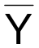 does is Σ(actual Y - predicted Y)² = 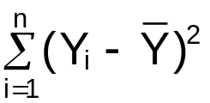 = SSTO = total sum of squares.

Measure of the “total” variability of the Y_{i}’s

Suppose we use again the knowledge of X to predict Y. We would then use 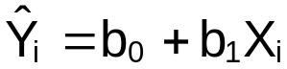 to predict Y

A measure of "how good" 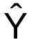 does is Σ(actual Y - predicted Y)² = 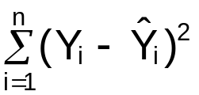 = SSE

The amount “gained” by doing the regression is

SSTO – SSE 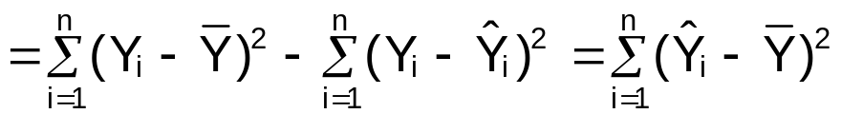
= SSR = regression sum of squares.

Example: College and HS GPA
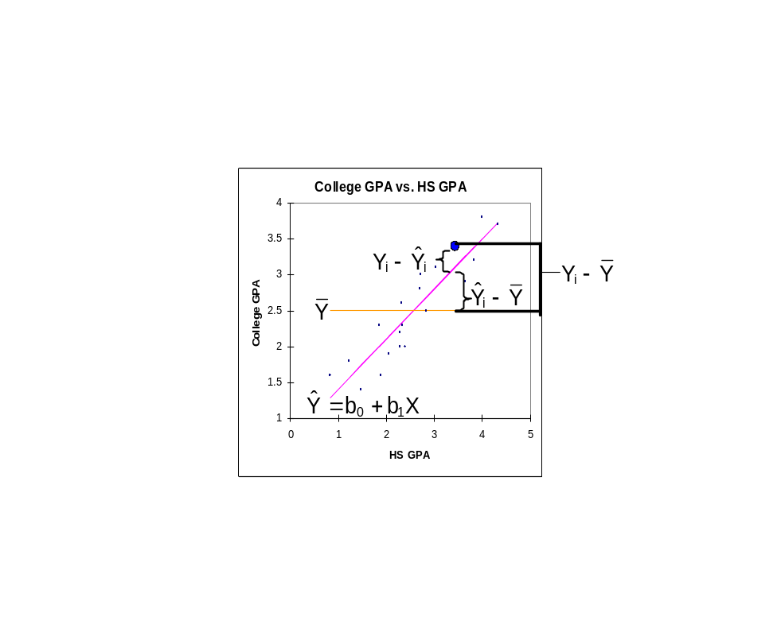
Note:
- SSTO = SSE + SSR
- SSTO has n-1 degrees of freedom (1 is lost through the estimation of μ by 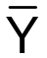).
- SSR has 1 degree of freedom from SSTO df – SSE df = SSR df
Note: SSR’s degrees of freedom corresponds to the number of predictor variables in the model.
- “Mean squares” are formed from dividing the sum of squares by their corresponding degrees of freedom.
  - MSE = SSE/(n-2)
  - MSR = regression mean square = SSR/1 = SSR
- Analysis of variance (ANOVA) table

Source of variation | df | SS | MS | F
Regression | 1 | SSR | MSR | F*=MSR/MSE
Error | n-2 | SSE | MSE
Total | n-1 | SSTO

Note that F* has an F-distribution with 1 degree of freedom for the numerator and n-2 degrees of freedom for the denominator. See p. 70 of KNN for a proof.

F-distribution review:

Equation (Do not need to know)
If Z (random variable) has an F-distribution with a d.f. in the numerator and b d.f. in the denominator, then
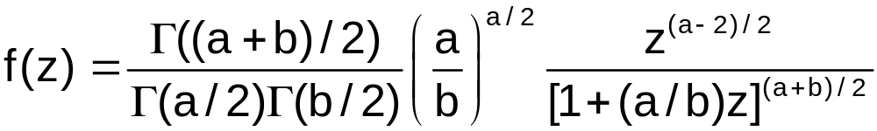 for 0<z<∞ and Γ(C)=(C-1)! if C is an integer; more generally, Γ(C)=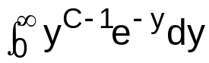

The percentiles (and critical values for hypothesis tests) to be found for the F-distribution are written as: F(1-α, num. df, den d.f.). This value comes from

P(Z < F(1-α, num. df, den d.f.))=1-α.

In other words, F(1-α, num. df, den d.f.) is the value that gives an area to the left of it of 1-α for a F-distribution with the specified degrees of freedom (α is the area in the right tail for the distribution). Alternatively, F(1-α, num. df, den d.f.) is the 1-α quantile from an F distribution.

Graph Example
If a=5 and b=20, then

Numerator degrees of freedom | 5
Denominator degrees of freedom | 20
F(0.9, 5, 20) | 2.16
F(0.95, 5, 20) | 2.71
F(0.99, 5, 20) | 4.10
F(0.999, 5, 20) | 6.46

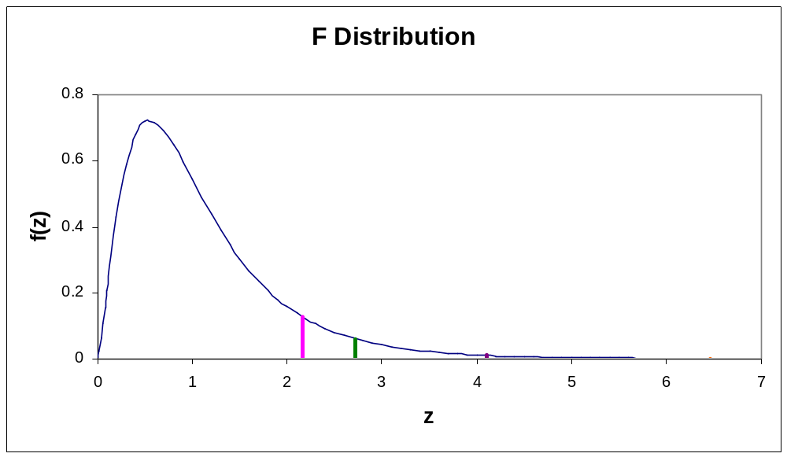

The above is from an interactive Excel file that I created for STAT 380 (see http://statistics.unl.edu/faculty/bilder/stat380/excel/F_Distribution.xls)

Quantiles and probabilities associated with the F-distribution can be easily found in R using qf() and pf(), respectively.

> qf(p = 0.9, df1 = 5, df2 = 20)
[1] 2.158227
> pf(q = 2.158227, df1 = 5, df2 = 20)
[1] 0.9

F Test of β₁=0 vs. β₁≠0:
1) H₀: β₁=0
H_{a}: β₁≠0
2) Test statistic: 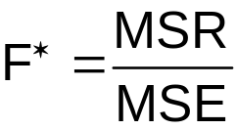

Note: E(MSR) = σ²+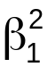Σ(X_{i}-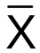)² and E(MSE)=σ² (proof is beyond the scope of this course)

When β₁≠0, then MSR generally will be larger than MSE. Thus, F∗>1. When β₁=0, then generally MSR will be close to MSE. Thus, F∗≈1.

Large values of F∗ greater than 1 cause rejection of the null hypothesis.

3) Critical value: F(1-α, 1, n-2)
- Reject or don’t reject H₀
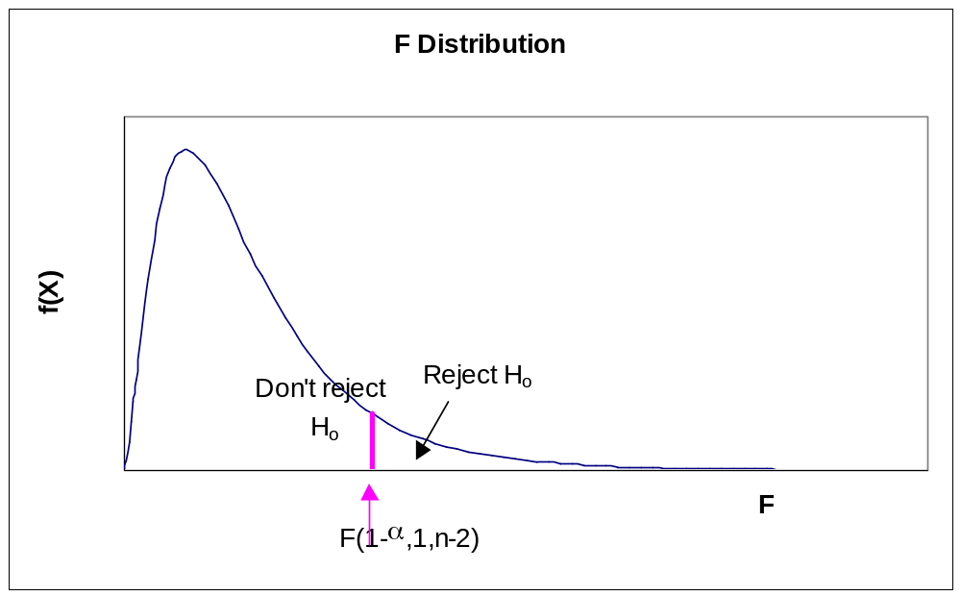

- Conclusion

Reject H₀ – X is linearly related to Y
Don’t Reject H₀ – There is not sufficient evidence to show that X is linearly related to Y

Note: ___ means to put in the above statements the variable name in the problem.

Using a p-value:
- Same
- P-value = P(F > F*) where F is a random variable with an F distribution that has 1 degree of freedom in the numerator and n-2 degrees of freedom in the denominator.
- State α
- Reject H₀ if p-value ≤ α; Don’t reject H₀ if p-value > α.
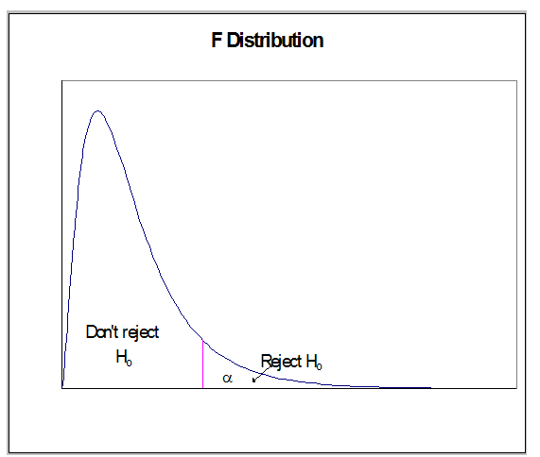

- Same

Example: HS and College GPA (HS_college_GPA_ch2.R)

Suppose α = 0.01 for the hypothesis test.

> #Fit the simple linear regression model and save the
results in mod.fit
> mod.fit<-lm(formula = College.GPA ~ HS.GPA, data = gpa)
> summary(mod.fit)

Call:
lm(formula = College.GPA ~ HS.GPA, data = gpa)

Residuals:
Min 1Q Median 3Q Max
-0.42294 -0.25711 -0.04094 0.27536 0.40334

Coefficients:
Estimate Std. Error t value Pr(>|t|)
(Intercept) 0.70758 0.19941 3.548 0.00230 **
HS.GPA 0.69966 0.07319 9.559 1.78e-08 ***
---
Signif. codes: 0 `***' 0.001 `**' 0.01 `*' 0.05 `.' 0.1 ` ' 1

Residual standard error: 0.297 on 18 degrees of freedom
Multiple R-Squared: 0.8354, Adjusted R-squared: 0.8263
F-statistic: 91.38 on 1 and 18 DF, p-value: 1.779e-08

> anova(mod.fit)
Analysis of Variance Table

Response: College.GPA
Df Sum Sq Mean Sq F value Pr(>F)
HS.GPA 1 8.0615 8.0615 91.38 1.779e-08 ***
Residuals 18 1.5880 0.0882
---
Signif. codes: 0 '***' 0.001 '**' 0.01 '*' 0.05 '.' 0.1 ' ' 1

The anova() function produces the full ANOVA table.

1) H₀: β₁=0
H_{a}: β₁≠0
2) = 91.38
3) F(1-α, 1, n-2) = F(0.99, 1, 18) = 8.29

This can be found in R using

> qf(p = 0.99, df1 = 1, df2 = 18)
[1] 8.28542

4) Since 91.38>8.29, reject H₀.
5) HS GPA is linearly related to college GPA.

Note that the p-value is 1.78∗10⁻⁸ = 0.000000178.

The F test and the t test (Section 2.1) for β₁=0 are equivalent; i.e. (t*)²=F* and [t(1-α/2,n-2)]² = F(1-α,1,n-2). In Chapter 6 this will no longer be true because the F test tests β₁=…=β_{p}=0 and the t test tests β_{i}=0.

2.8 General linear test approach

Skip for now

2.9 Descriptive measures of association between X and Y in the regression model

SSTO = SSE + SSR

SSTO measures the “total” variability of the Y_{i}’s
SSE measures the remaining variation in the Y_{i}’s after the regression has been done.
SSR is the variability in Y “explained” by doing the regression

The percent reduction in the total variability is:

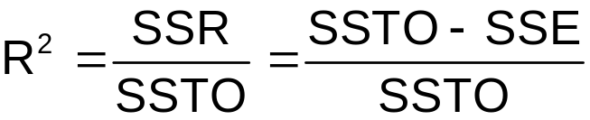

R² is called the coefficient of determination.

Measurement of how much we improved in estimating Y by using X (and thus 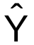) instead of using only .

Notes:
- 0 ≤ R² ≤ 1
- 100∗R²% of the variation in Y can be “explained” by using X to predict Y; i.e., the error in predicting Y can be reduced by 100∗R²% when the regression model is used instead of just 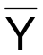

- R² is a measure of "fit" for the regression line
0 0.25 0.5 0.75 1.0
Bad Fit Good Fit

- r = 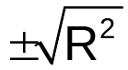 is the coefficient of correlation (see p. 76 of KNN). The square of this is the coefficient of determination in simple linear regression.

Example: Sales and Advertising

SSTO=6 and SSE=1.1
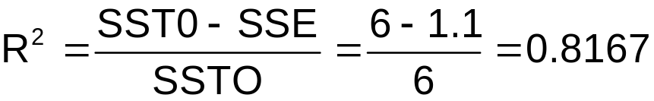
- 81.67% of the variation in sales can be explained by using advertising to predict sales.
- 81.67% of variation in sales is due to advertising

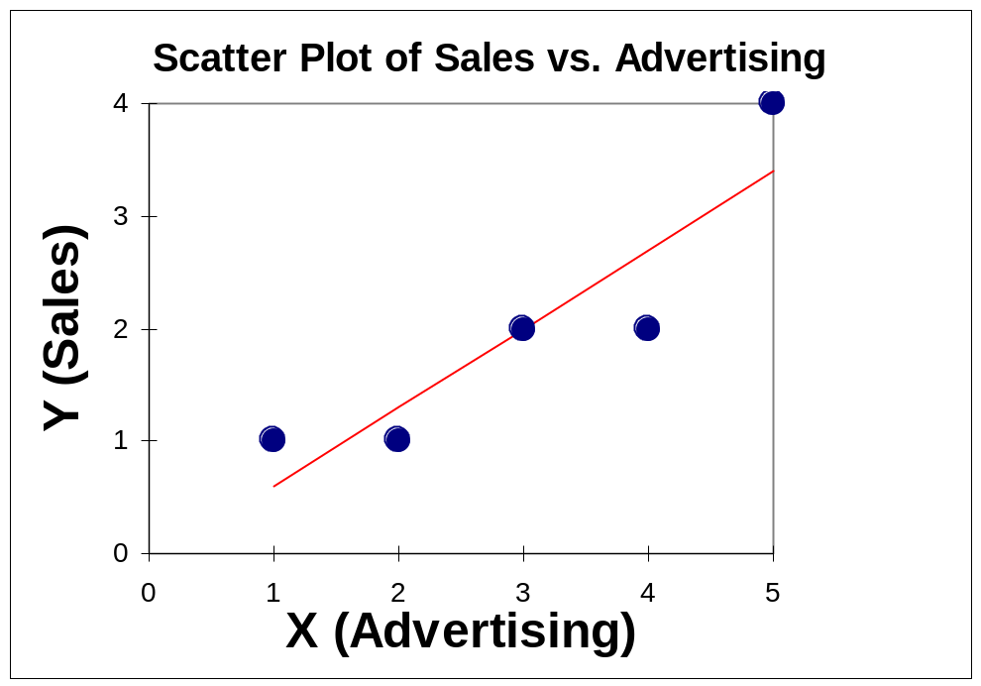

Example: : HS and College GPA (HS_college_GPA_ch2.R)

> #Fit the simple linear regression model and save the
results in mod.fit
> mod.fit<-lm(formula = College.GPA ~ HS.GPA, data = gpa)
> summary(mod.fit)

Call:
lm(formula = College.GPA ~ HS.GPA, data = gpa)

Residuals:
Min 1Q Median 3Q Max
-0.42294 -0.25711 -0.04094 0.27536 0.40334

Coefficients:
Estimate Std. Error t value Pr(>|t|)
(Intercept) 0.70758 0.19941 3.548 0.00230 **
HS.GPA 0.69966 0.07319 9.559 1.78e-08 ***
---
Signif. codes: 0 `***' 0.001 `**' 0.01 `*' 0.05 `.' 0.1 ` ' 1

Residual standard error: 0.297 on 18 degrees of freedom
Multiple R-Squared: 0.8354, Adjusted R-squared: 0.8263
F-statistic: 91.38 on 1 and 18 DF, p-value: 1.779e-08

- 83.54% of the variation in College GPA can be explained by using HS GPA to predict college GPA.
- The model fits the data relatively well.
- See the plot on p. 2.35 which demonstrates what R² measures.
- Look at the college GPA and Pizza example’s R²

Warning
- Use R² as a measure of fit when the sample size is substantially larger than the number of variables in the model; otherwise, R² may be artificially high.

Example: Suppose the sample model is =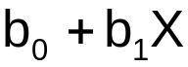, and a random sample of size 2 is used to calculate b₀ and b₁. Then a scatter plot with the estimated regression line plotted upon it would look something like:
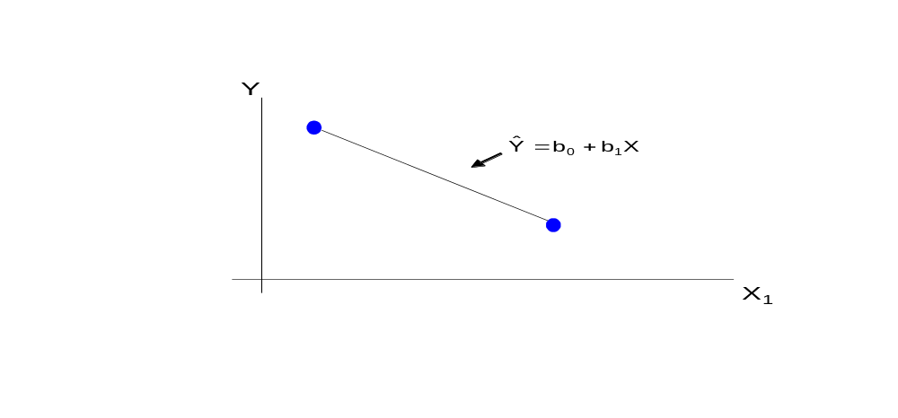
and R² = 1. In this case the sample size is not substantially larger than the number of variables in the model causing R² to be artificially high.

- R² is only measuring the linear relationship for this type of model.
- R² is a measure of how the sample model fits in the sample only.

Read sections:

2.10 Considerations in applying regression analysis

Please see this on your own

2.11 Case when X is random

Suppose X is also a random variable in addition to Y. Basically, the same results occur as before when we considered X to be a random variable. The model form changes a little when X is a random variable to

E(Y|X) = β₀ + β₁X

so that now a conditional expectation is used. All of the inference results are derived by using a multivariate normal distribution for Y and X. Still, estimates of β₀ and β₁ and corresponding inferences remain the same as if X was a constant. Because of this equivalence, KNN focus on X being constant for the remainder of the book. For more information about a regression model when X is a random variable (KNN call this the “correlation model”), please see p.78 – 83. STAT 970 talks about this model in more detail because of its STAT 882-3 prerequisite, which is needed to fully understand the model.

